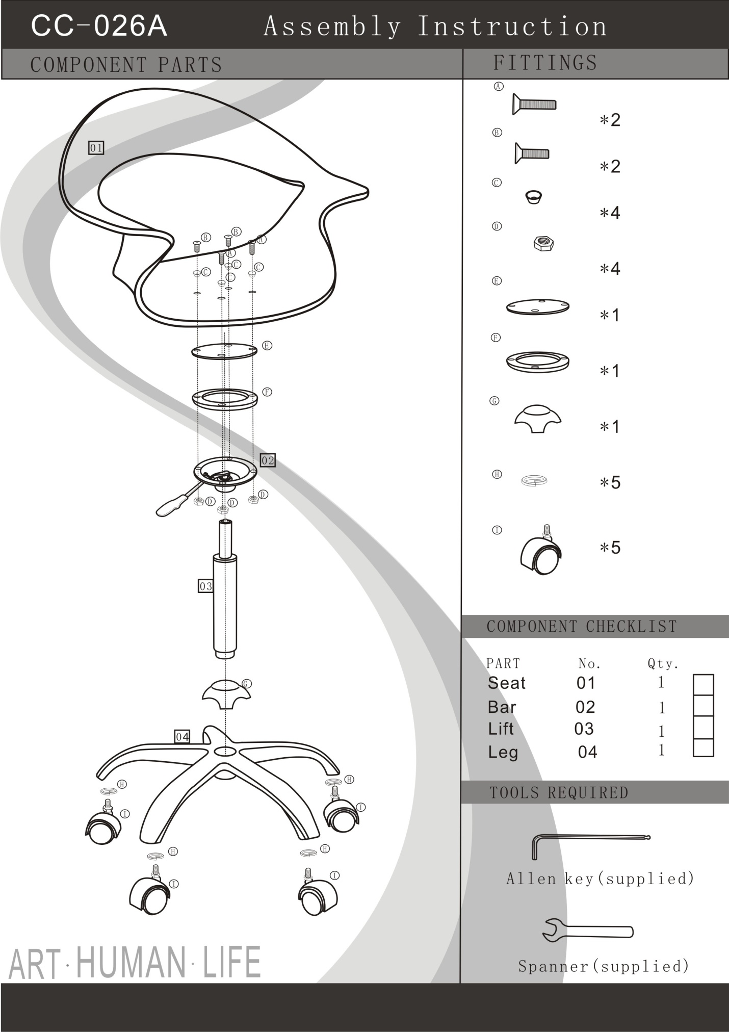
INSTRUCTIONS FOR CC-026A-CLEAR

Place round plate (part E), “O” ring (part F) and the lever mechanism (part 02) under the seat, lining up the holes
For the back two holes of the seat, place the small bolt (part B) into the ferrule (part C) then through the top hole of the chair (part 01), the round plate (part E), “O” ring (part F) and the lever mechanism (part 02) and screw the nut (part D) onto the bottom end of the small bolt (part B).
For the front two holes of the seat, place the large bolt (part A) into the ferrule (part C) then through the chair (part 01), round plate (part E), the “O” ring (part F) and the lever mechanism (part 02) and screw the nut (part D) onto the bottom end of the large bolt (part A).
Use the allen key and Spanner wrench to ensure all nuts and bolts are tightened.
Insert the piston (Part 03) into assembled seat (following above instructions)*
Place the base covering (part G) over the base (part 04) and insert the piston (part 03)
To attach the wheels:
Place the lock washer (part H) over bottom of leg where the hole is for the wheel, and screw the castor (part I) into the bottom of each leg.

*NOTE: Make sure there is no cap on top of the Piston. It will cause the piston not to go up and down if left on.

