|  |  |  |  |
| --- | --- | --- | --- |
| **PARTS LIST** | |  |  |
|  |  |  |  |
| **LABEL** | **PICTURE** | **DESCRIPTION** | **QTY** |
| **A** |  | KEEL FRAME | 2 |
| **B** |  | HEADBOARD | 1 |
| **C** |  | SIDEBOARD | 2 |
| **D** |  | FOOTBOARD | 1 |
| **E** |  | SIDE LEG | 4 |
| **F** |  | MIDDLE LEG (this needs to be assembled) | 2 |
| **G** |  | BOLT | 8 |
| **H** | |  | | --- | | H1 | | METAL GASKET | 8 |
| **I** |  | WASHER RING | 8 |
| **J** | |  | | --- | | J1 | | NUT | 4 |
| **K** |  | SCREW | 2 |
| **L** |  | SCREW | 2 |
| **M** |  | WRENCH | 1 |
| **N** |  | METAL BRACKET | 4 |



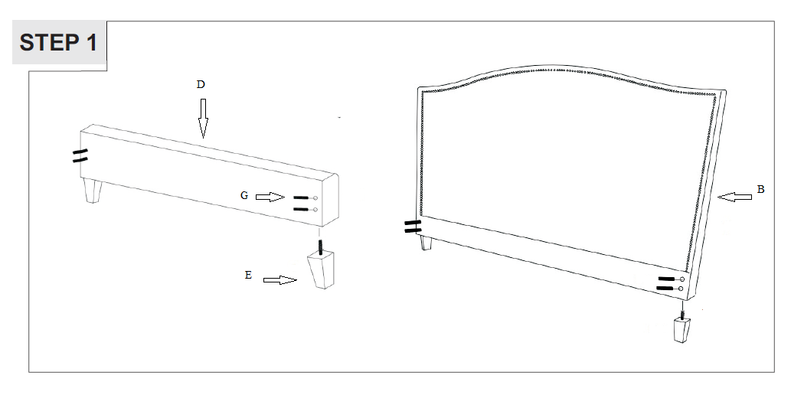

Step 1: Screw PART E (side legs) into the bottom of PART D (footboard) and PART B (headboard).

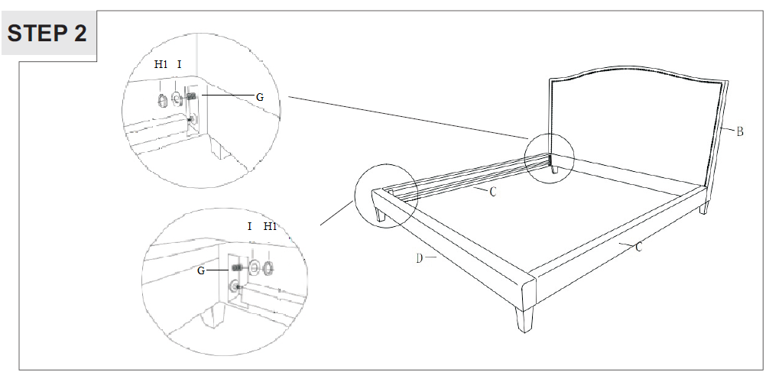

Step 2: Feed PART I (washer ring) and then PART H1 (metal gasket) onto PART G (bolt). Use this bolt set to loosely connect PART C (side rails) to PART B (headboard). This will be done for both sides. Use the bolt set to loosely connect PART C (side rails) to PART D (footboard). This will be done for both sides. Use PART M (wrench) to tighten all bolts.

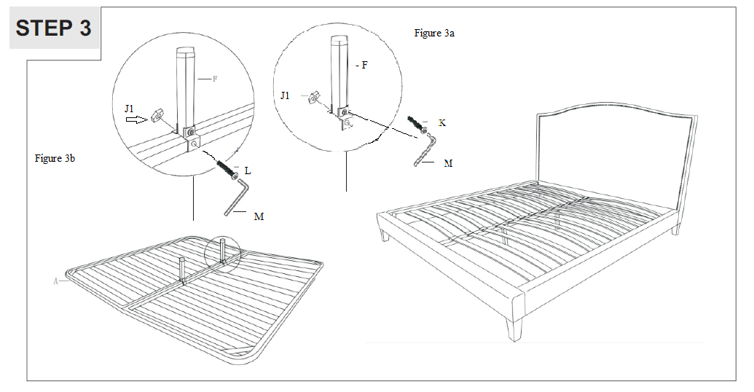

Step 3:

Figure 3a (this is the assembly of PART F, which needs to be done directly on to PART A)

Place both of PART A (keel frame) together upside down and push the centers together. Place PART N (metal bracket) onto each side of PART A then insert the middle leg. Insert PART K (Screw) and screw PART J1 (nut) over the end of the bolt. Tighten with PART M (wrench). Repeat step for second leg.

Figure 3b (this is the assembly of PART F onto PART A (keel frame)

With figure 3a completed, and partially attached to the center supports, Insert PART L (screw) to attach PART F (middle leg) and screw PART J1 (nut) onto the end of the screw. Tighten with PART M (wrench). Repeat step - Place PART F (middle leg assembled) onto both center supports of PART A (keel frame). Insert PART L (screw) to attach PART F (middle leg) and screw PART J1 (nut) onto the end of the screw. Tighten with PART M (wrench) - for second leg.

Turn completed PART A (keel frame) with attached PART F (middle legs) right side up and place into bed frame.