B-55 Bed Assembly Manual

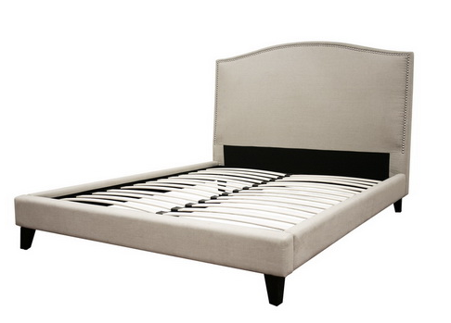
Please allow for enough space when assembling this product.

B-55 Hardware KIT
Accessory Code | Quantity | Accessory
A | 8 PCS
C | 10 PCS
N | 30 PCS
 | 1 PC
Y | 2 PCS
Additional accessories | ******
32 pcs

4 pcs

Step 1: Lay the headboard on a flat surface, such as the floor, along with the 2 side rails and the foot board.

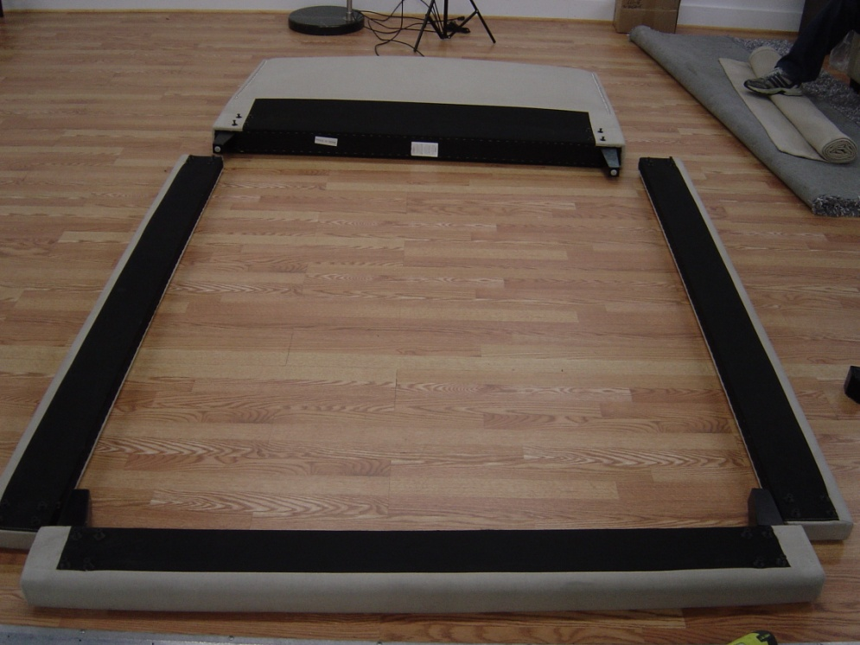

Please note: there are 8 - 30*8mm bolts attached to the headboard, there are 16 total 30*8mm bolts attached to (2) sideboards and there are 8 – 30*8mm bolts attached to the footboard. Another side note: the 4 legs are already attached to the side rail and foot board.

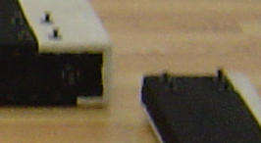

Step 2: Along the sides of the side rails (4 on each) and headboard (1) and footboard (1), there will be markings as to where to put the “C” brackets. Attach all the “C” brackets with the “N” screws. There will be pre-drilled holes.

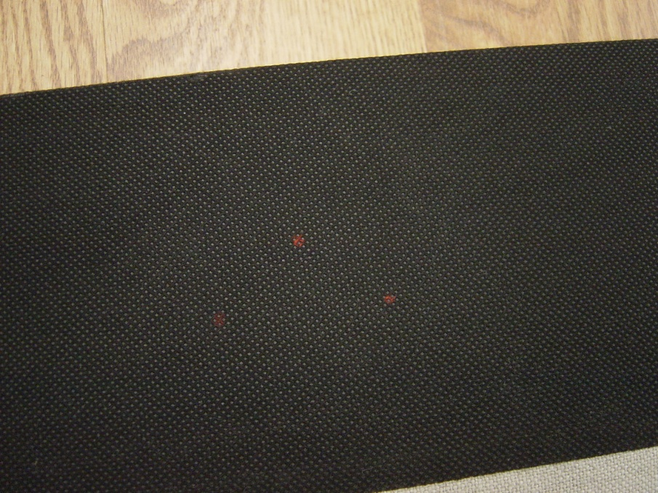

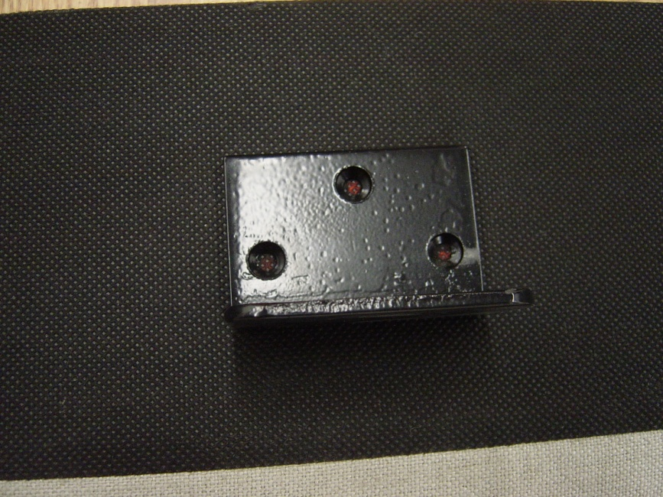

Step 3: Remove all “M” bolts from the headboard and side rail and footboard. Attach “A” brackets with “M” bolts to the side rails (loosely, these will be adjusted later).
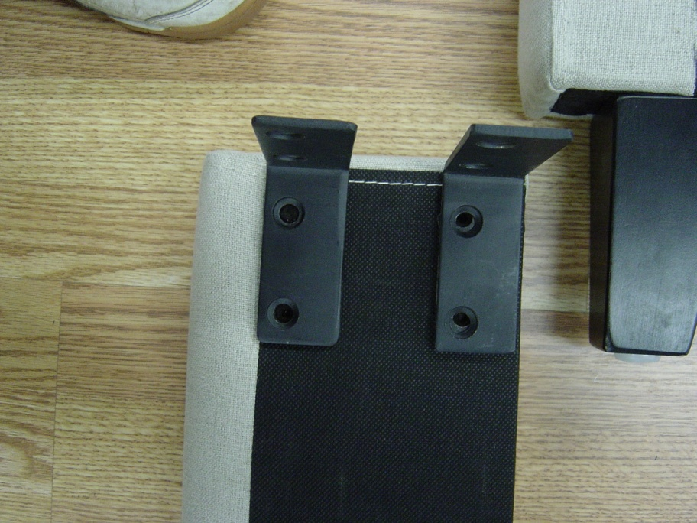

Step 4: Stand up headboard, attach 1 side rail with “A” brackets and “M” bolts to the headboard, to tighten the bolts, tighten in alternating order.

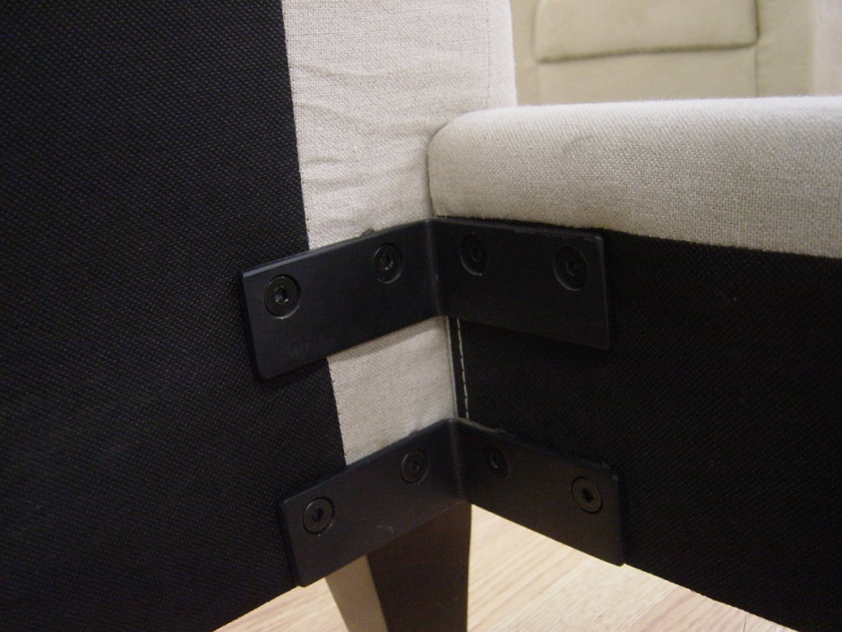

Stand up foot board, attach 1 side rail with “A” brackets and “M” bolts to the headboard, to tighten the bolts, tighten in alternating order.
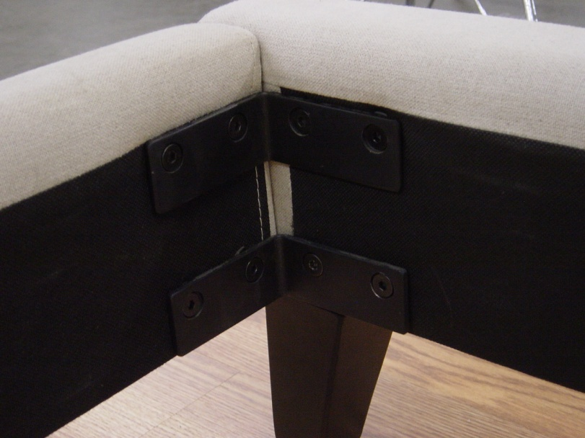

Repeat step 4 until all sides are assembled.

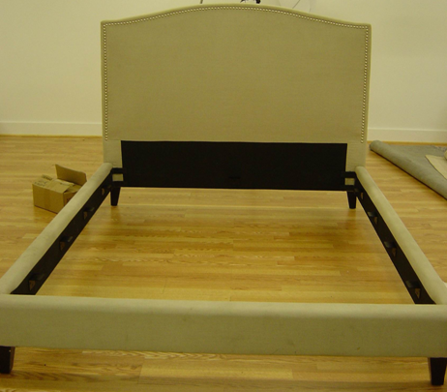

Step 5: Attach “Y” leg to the center of the slat. Place the slat on top of the “C” brackets inside the side rails.

